EC2- Elastic Compute Cloud

- Creating a sample Ec2 instance.
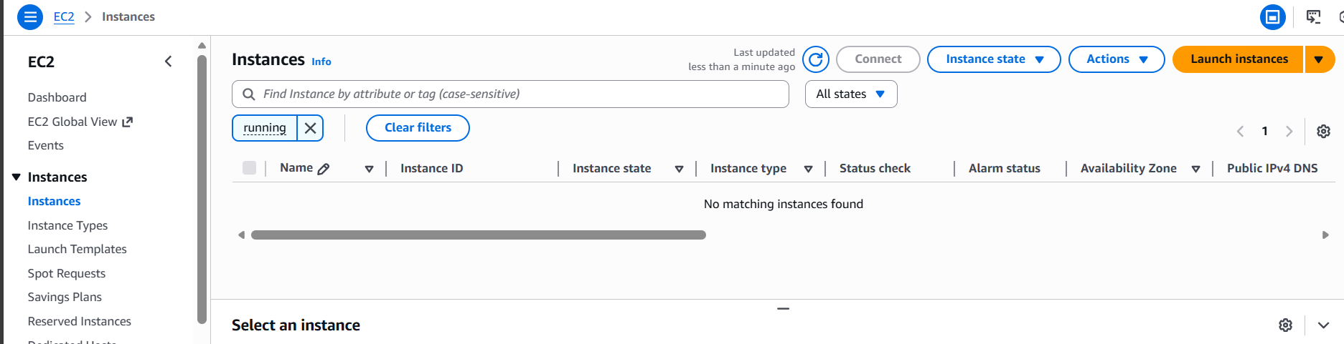
- Select -> Launch Instance
- Name: Sample
- OS Image: Amazon Linux
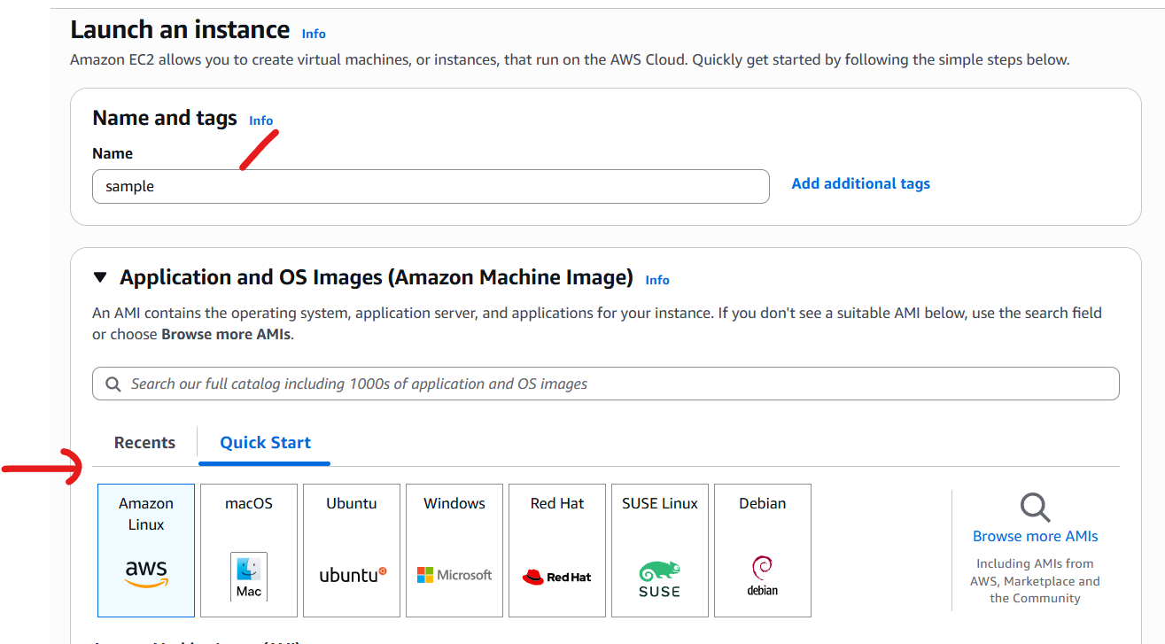
- AMI: as per requirement
- Instance Type: Server configuration
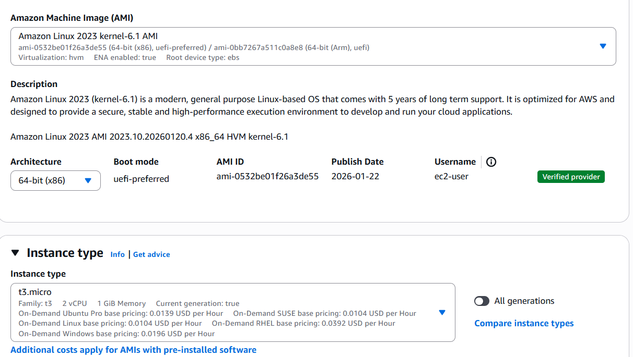
- Create a keypair if not available
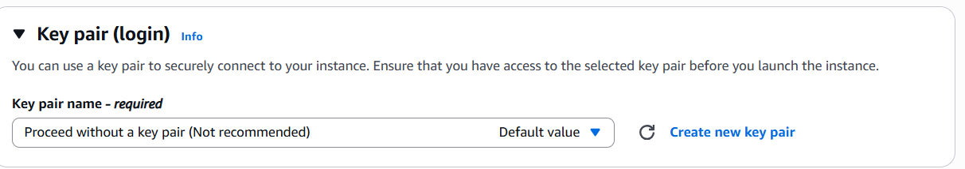
- Select VPC manually if required otherwise it select default VPC
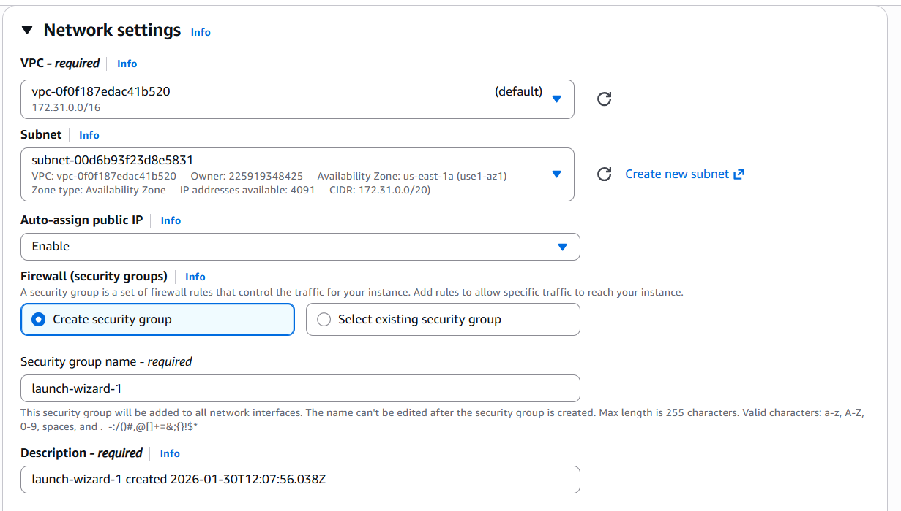
- Select the size of root volume. If you want to add additional volume you can here.
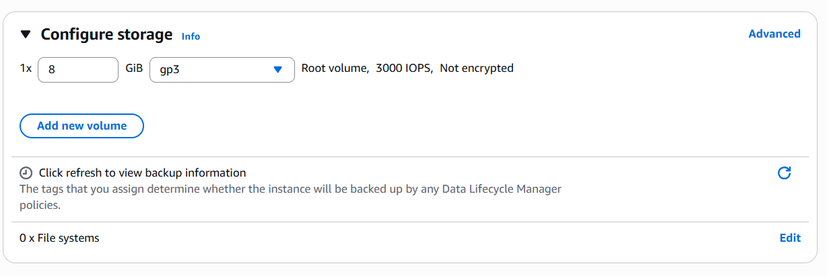
- No.of instance you need to choose.
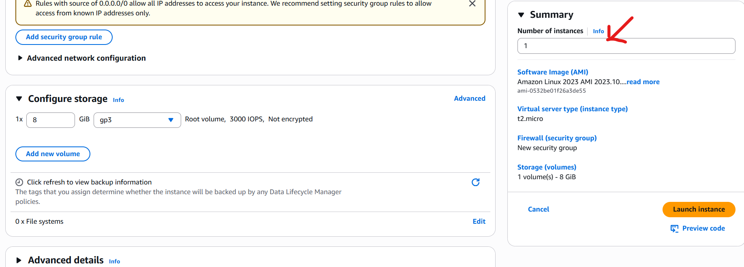
- Click – Launch instance.

- AMI: Amazon Machine Image:
An Amazon Machine Image is a pre-configured template of a virtual machine environment in AWS. It includes the OS, application server, applications and other configurations needed to deploy a VM.
Use cases:
- Rapid instance deployment of EC2 instance
- Load balancing and scaling
- Environment Cloning
- Disaster Recovery

